ST. XAVIER’S COLLEGE

**(Affiliated to Tribhuvan University)**

Maitighar, Kathmandu



**Computer Graphics Lab Assignment #7**

**Translation, Rotation and Scaling**

**Submitted by:**

Hemanchal Joshi

013BSCCSIT021

**Submitted to:**

|  |  |
| --- | --- |
| **Er. Anil Sah**  **Lecturer Department of Computer Science** |  |

**Date of Submission: September 4, 2015**

**SOURCE CODE:**

//---------------------------------------------------------------------------

#include <vcl\vcl.h>

#pragma hdrstop

#include<math.h>

#include "scale.h"

//---------------------------------------------------------------------------

#pragma resource "*.dfm"

TForm1 *Form1;

//---------------------------------------------------------------------------

__fastcall TForm1::TForm1(TComponent* Owner)

: TForm(Owner)

{

}

//---------------------------------------------------------------------------

void __fastcall TForm1::TranslateClick(TObject *Sender)

{

int ttx,tty,i,j;

int h=input->Height;

int w=input->Width;

ttx=StrToInt(Edit1->Text);

tty=StrToInt(Edit2->Text);

int a,b;

for(i=0;i<=h;i++){

for(j=0;j<=w;j++){

a=i+ttx;

b=j+tty;

output->Canvas->Pixels[a][b] = input->Canvas->Pixels[i][j];

}

}

}

//---------------------------------------------------------------------------

void __fastcall TForm1::RotateClick(TObject *Sender)

{

int angle,i,j;

float radian;

int h=input->Height;

int w=input->Width;

angle=StrToInt(Edit3->Text);

radian=(angle*3.14)/180;

int a,b;

for(i=0;i<=h;i++){

for(j=0;j<=w;j++){

a=i*cos(radian)-j*sin(radian);

b=i*sin(radian)+j*cos(radian);

output->Canvas->Pixels[a][b] = input->Canvas->Pixels[i][j];

}

}

}

//---------------------------------------------------------------------------

void __fastcall TForm1::ScaleClick(TObject *Sender)

{

int i,j;

float ssx,ssy;

float radian;

int a,b;

int h=input->Height;

int w=input->Width;

ssx=StrToFloat(Edit4->Text);

ssy=StrToFloat(Edit5->Text);

for(i=0;i<=h;i++){

for(j=0;j<=w;j++){

a=i*ssx;

b=j*ssy;

output->Canvas->Pixels[a][b] = input->Canvas->Pixels[i][j];

}

}

}

//---------------------------------------------------------------------------

**OUTPUT SCREEN:**

1. **Translation**

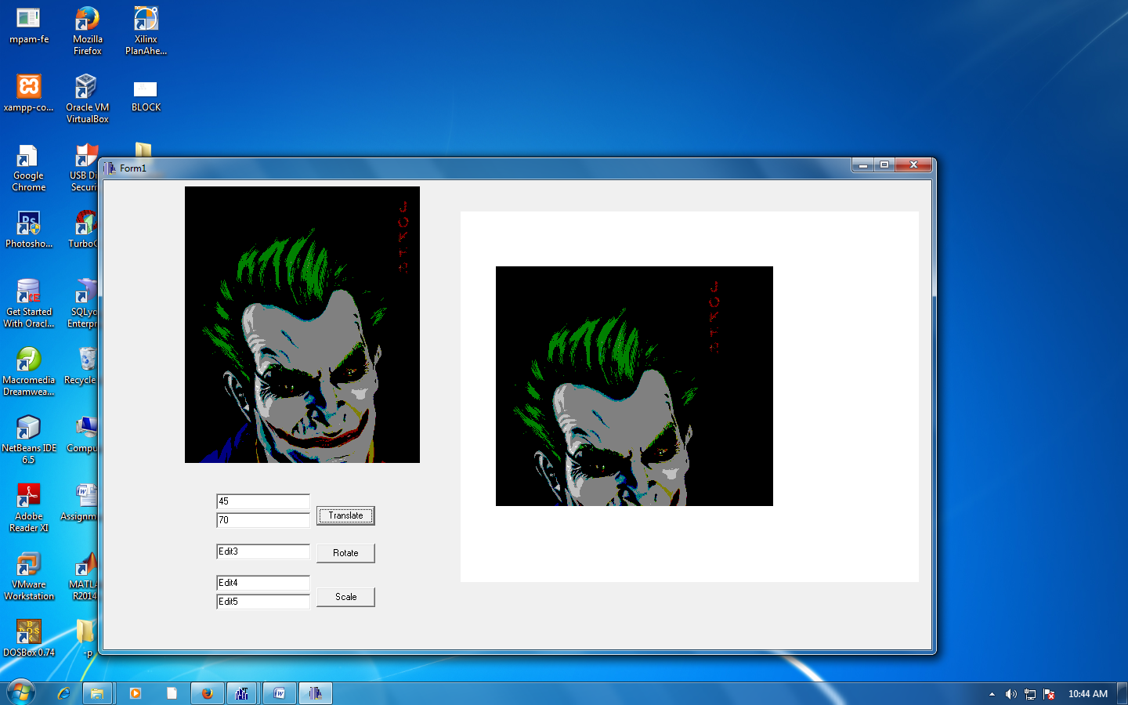

1. **Rotation**

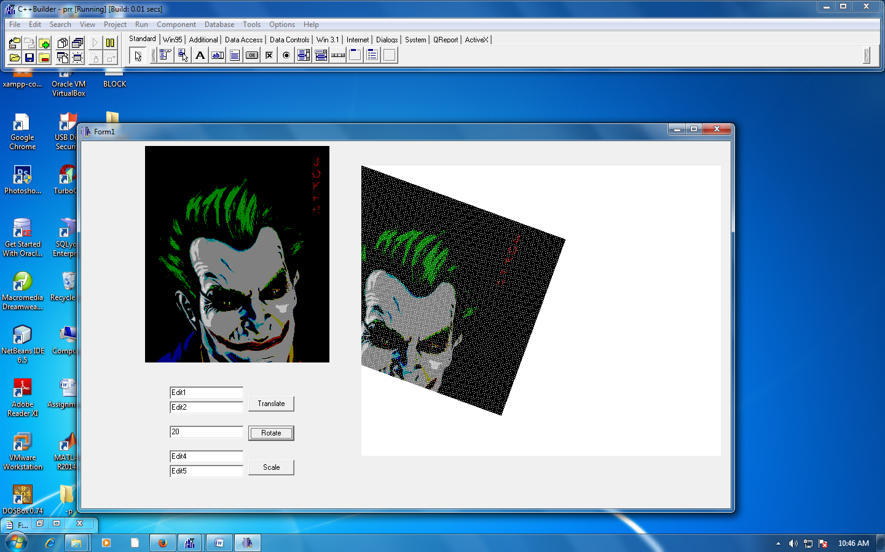

1. **Scaling**

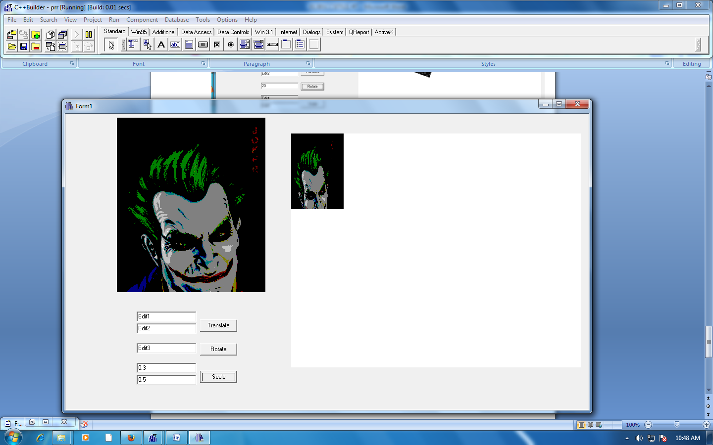

**CONCLUSION:**

Hence the translation, rotation and scaling operations were performed and shown in the output screen as represented above.